Chapter 5: Supply Side Water Interventions

Introduction
- All options evaluated prior to drought as per Integrated Water Resource Plan (IWRP)
- During crisis, projects selected to increase water supply in the short term
- Distinction between short term emergency water augmentation in the midst of the crisis and long term investments.
- Main projects investigated for crisis response are: desalination, groundwater extraction, water reuse

Crisis Interventions

Desalination projects
- Originally 9 temp desalination projects proposed to yield 50MLD, as well as 50MLD through a desalination barge (ref: advancing water resilience CCT)
- Due to cost/complexity/changing conditions - only three temporary plants followed through during crisis to yield a total of 16MLD once all operational
- Temp desalination expensive, complex, and still takes time to implement (first project online in May 2018 following RFI in June 2017)
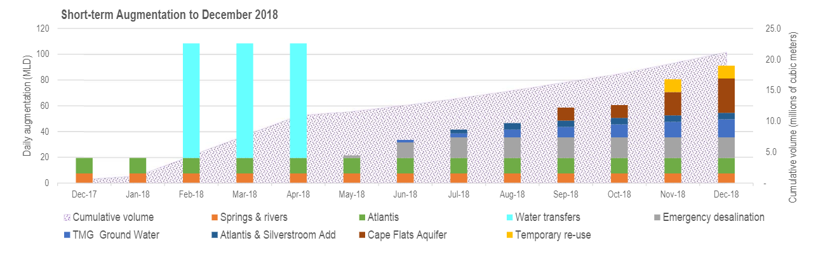

NB Also discuss the impact on emissions and biodiversity in the water where salt may be dumped: https://www.scientificamerican.com/article/the-impacts-of-relying-on-desalination/

Aquifer extraction
  - Timelines to implement / Costs / Environmental impacts / Yield
  - Public perception

Water Reuse

Long term water supply
- Non-surface water more expensive than compared with rain-fed dams, so surface water will remain the dominant source, but resilience to be increased through augmentation from different sources that are less dependent on rainfall in specific regions (ref Water outlook report)

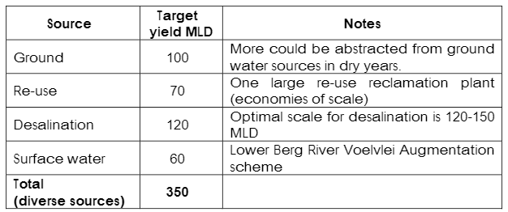
(Ref: 2018 water outlook report)

Early Warning Systems of drought (Prediction of Supply)
- Monitoring of dam levels (link)
- Usefulness of rainfall models to predict rainfall
- Lack of diversity in water sources impact on predictions of supply
- Predictions of water demand patterns

